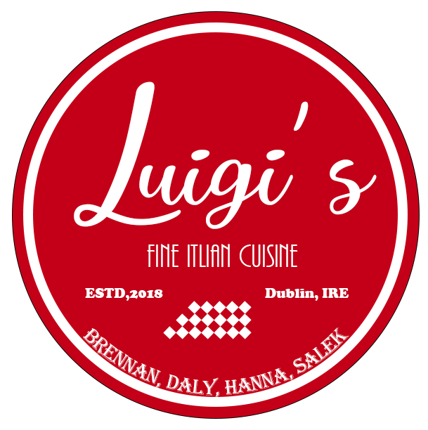

Web Design Project

# Presented by

# Arkadiusz Salek 17163153

# Ross Daly 14102943

# Gavin Hanna 17164974

# Table of Contents

|  |  |
| --- | --- |
| Introduction | 3 |
| Planning | 4 |
| Conceptual Development | 5 |
| Survey and Persona | 9 |
| Usability Tests | 12 |
| Conclusion | 13 |
| Appendix | 14 |
| References | 16 |

# Introduction

For our project, we decided to create an attractive website for a local Dublin based restaurant. We decided on a restaurant because we thought it could contain a number of connected web pages, each page being different enough to give us an opportunity to express some creativity in the design.

We quickly decided on an Italian restaurant, not only because we all love the cuisine, but also because knew we could make an appealing design that would reflect the feeling of this particularly style of food and vibe of restaurant.

The problems we are attempting to solve in this design, is to convey a sense of fresh and excellent quality food, with a good atmosphere, using design rather than a simple description.

The market size in Dublin is obviously quite large, however we noticed a trend in the websites of most of these restaurants. They tended to be lacking in their design. Some websites simply had very little information, such as “Ristorante Romano”1 or had too much going on, a kind of information overload, as in “Pinocchio”2

We decided to create a simple, yet intuitive website that would contain all the information a visitor might want, without bombarding the visitor with extra information.

# Planning

Initially we decided together on the type of website we wanted to build, as discussed in the introduction. We had a conversation regarding what we wanted to achieve and what direction we wanted to move in. Our first step in building the website itself came in the form of the construction of wireframes. From here we decided on basic site wide styling. The colours and the banner style of the header, including the style of the navigation and footer. This went through a few iterations, changing the colour and the position of the site logo and navigation buttons, before settling in the current configuration.

After this step, we divided up the site’s web pages between each member, creating 2 pages each. The gallery itself came quite late in the websites development and doesn’t show up on the wireframes, however it follows the websites style and structure.

The page breakdown is as follows:

|  |  |
| --- | --- |
| *Arkadiusz* | gallery and reservation pages*.* |
| *Ross* | about and menu pages. |
| *Gavin* | index and contact pages, as the index was the simplest page, he also handles the mobiles navigation menu. |

Once the individual pages were complete, we decided to make the menu page fully responsive in any viewport as we considered it likely to be the most viewed page on the site.

# Concept development

The development wireframes were constructed as follows.

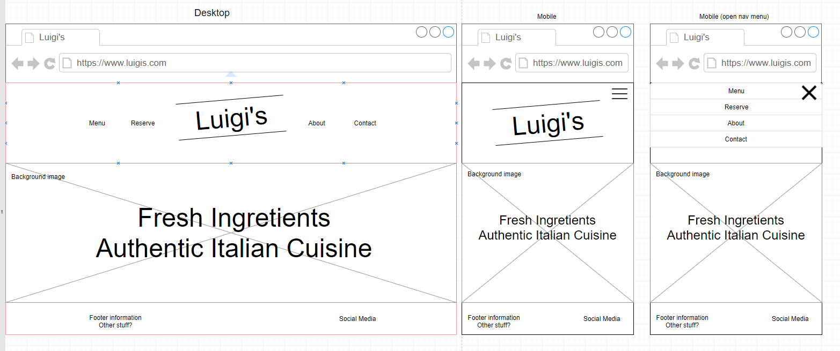Index.html, including mobile version and mobile version with mobile nav open.

menu.html

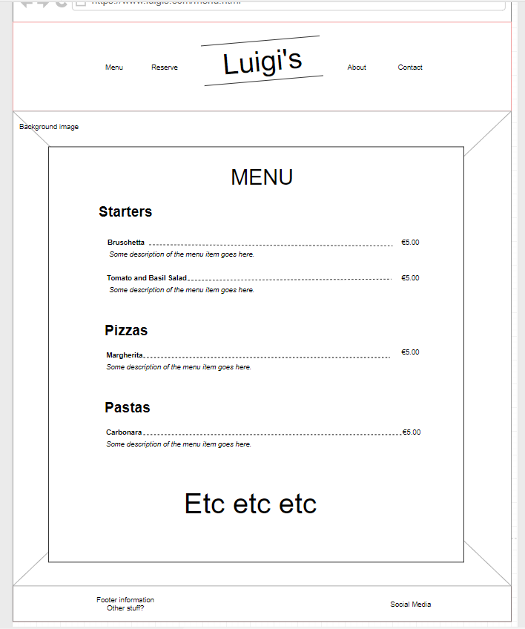

reserve.html

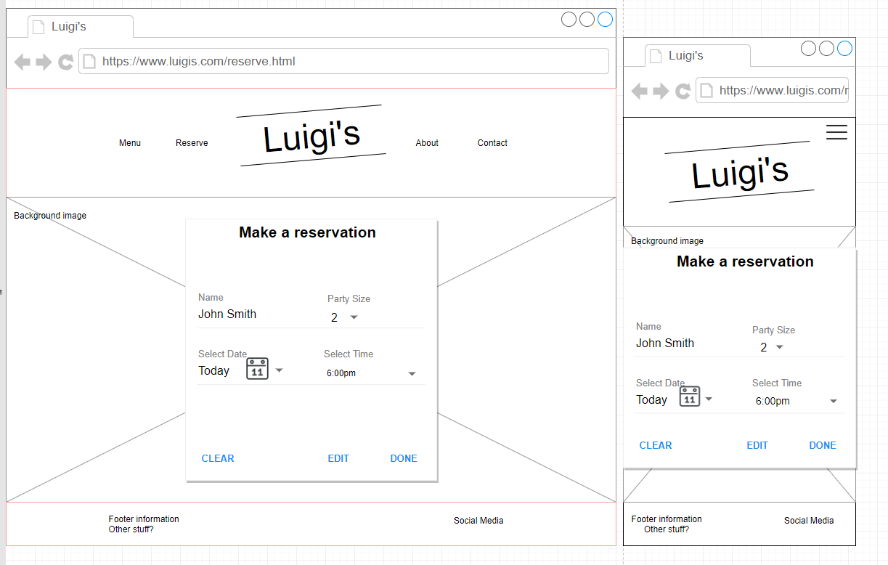

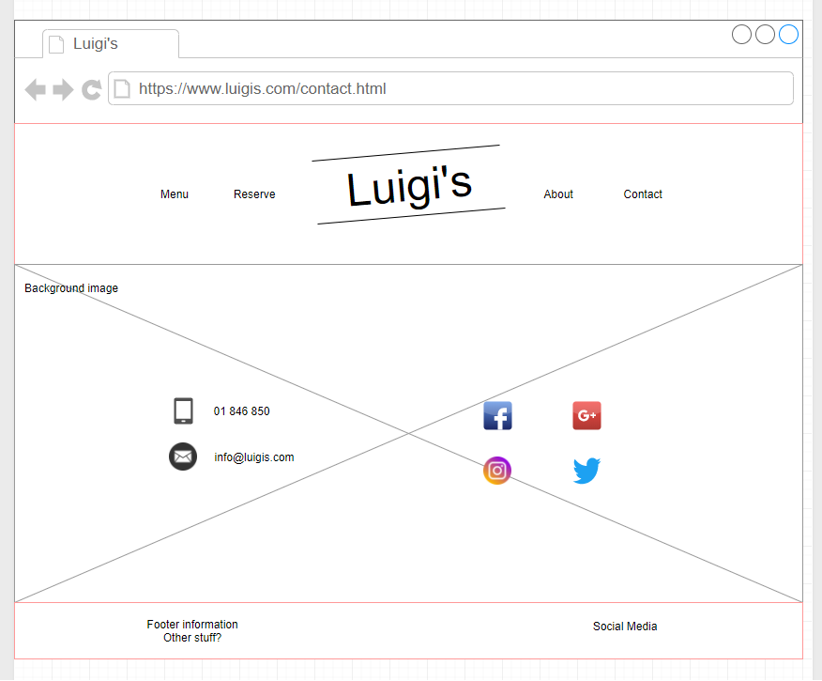contact.html

# Survey and Persona

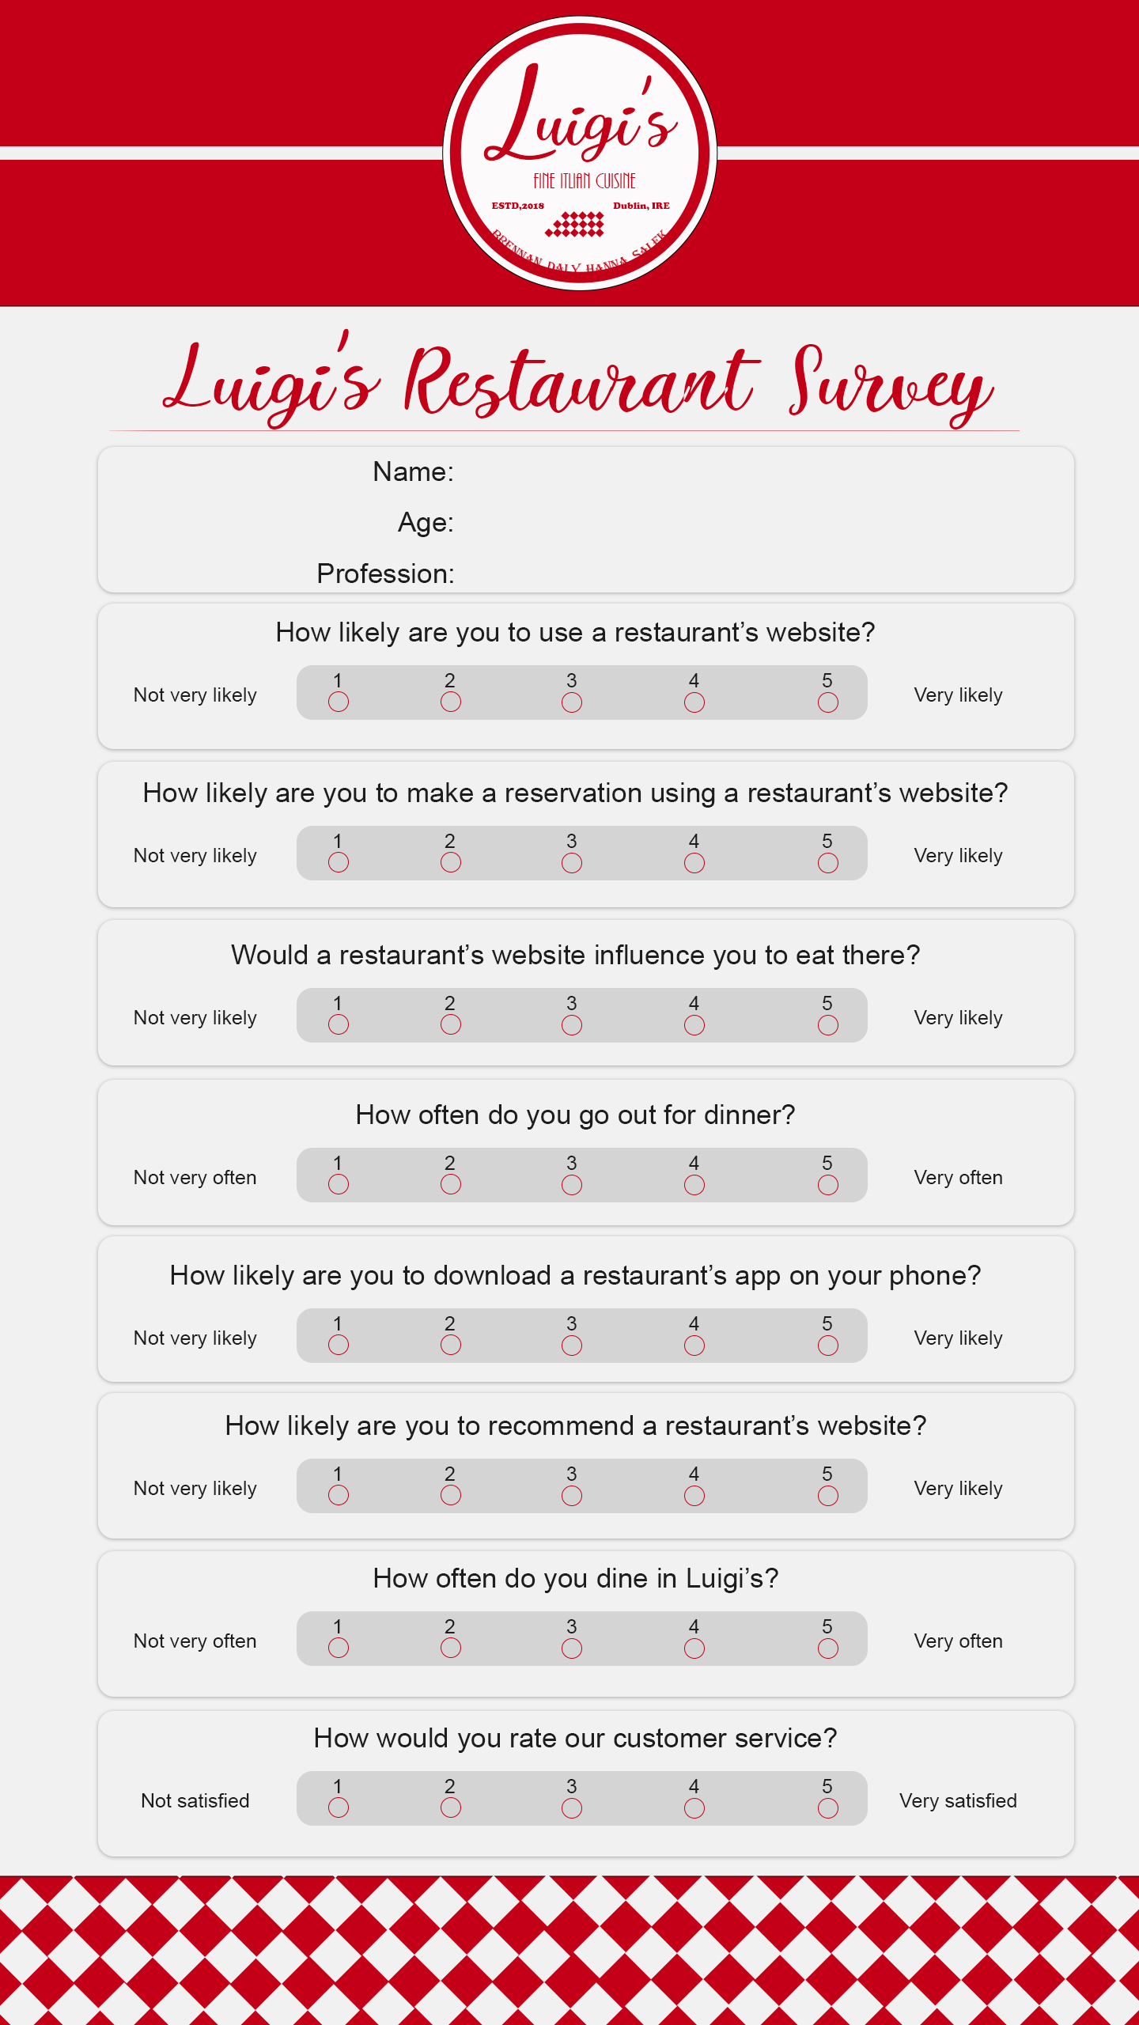Each persona was based on the results of the following survey, carried out by each group member:

The personas are as follows:

Arkadiusz

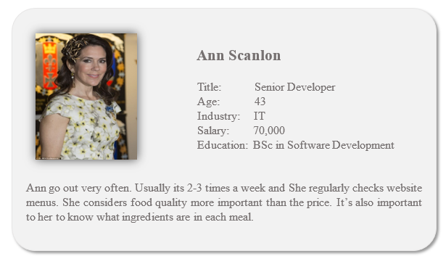

Ross

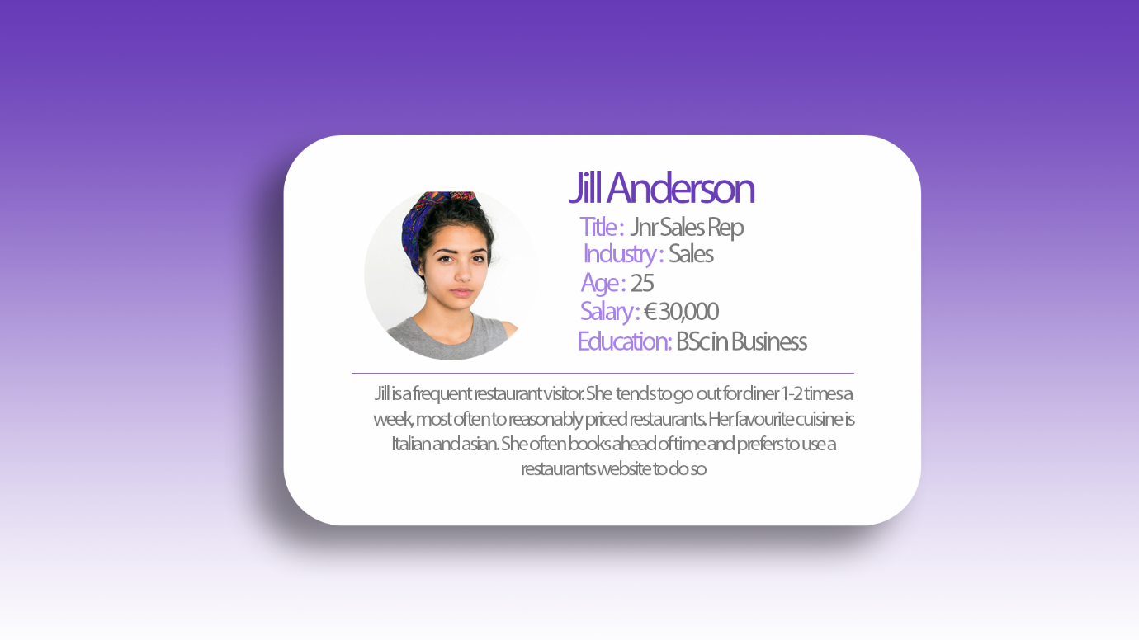

Gavin

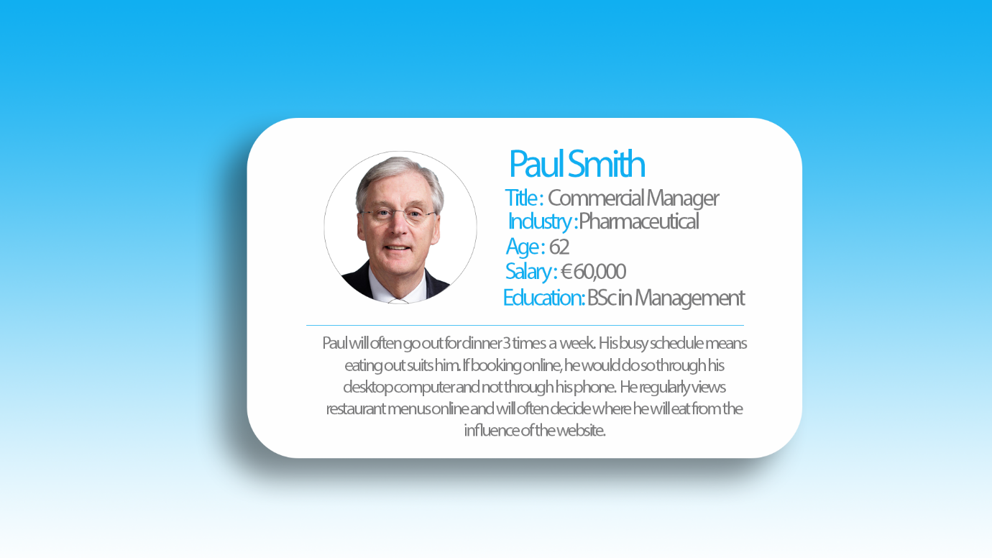

# Usability Test Results

Please see attached document for Usability Tests.

# Conclusion

We like to think the site as it stands now succeeded in achieving most, if not all of our goals which we had set out to achieve at the beginning. We believe it conveys a sense of good, fresh food to the viewer, and doesn’t bombard them with extra unimportant information. We hope it that the website creates a sense of inviting the viewer to the restaurant.

There are a few additions to the site that might improve its usability and navigability. If we had more time we could have implemented more robust semantic HTML, providing a better experience for disabled viewers using technologies such as screen readers to access our website. Completing the responsive design element of the website would also allow a friendly and intuitive mobile experience for a large percentage of visitors, however we simply didn’t have enough time to fully implement this feature.

# Appendix

The following are some screenshots of out completed 365 Planner board.

We had grouped tasks into 3 sections, “To do”, “Next Up” and “Finished”.

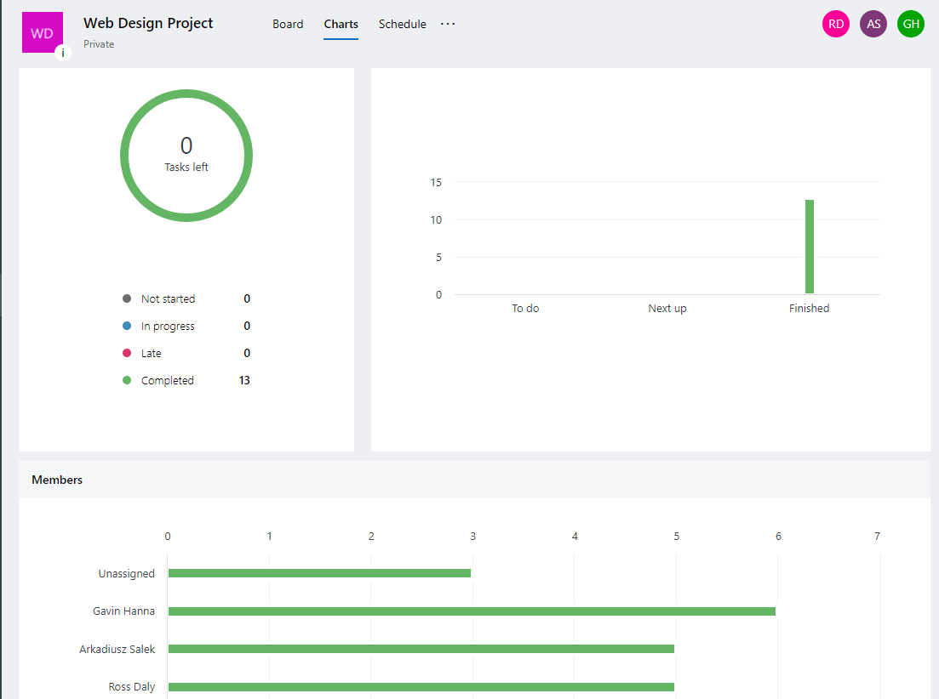

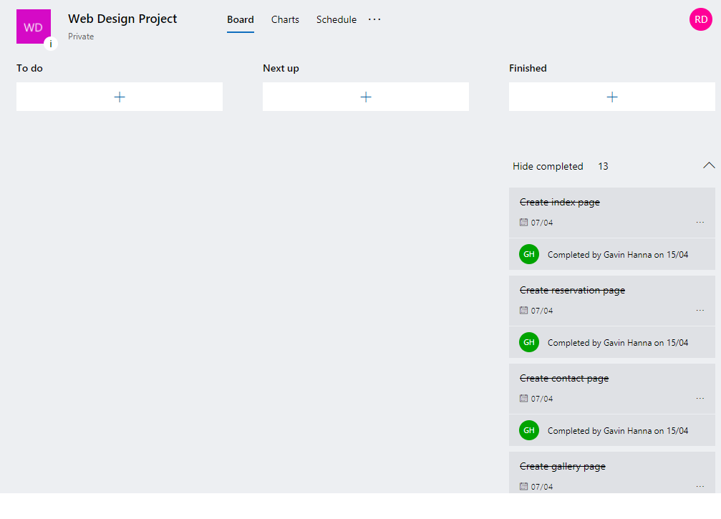

# References

1. Ristorante Romano - <http://ristoranteromano.business.site/>
2. Pinocchio  
    - http://www.flavourofitaly.net/content/116-pinocchio-restaurant-temple-bar